Windjammer Café Wins Mocktail Contest

HEROtini Challenge Raises $27,000

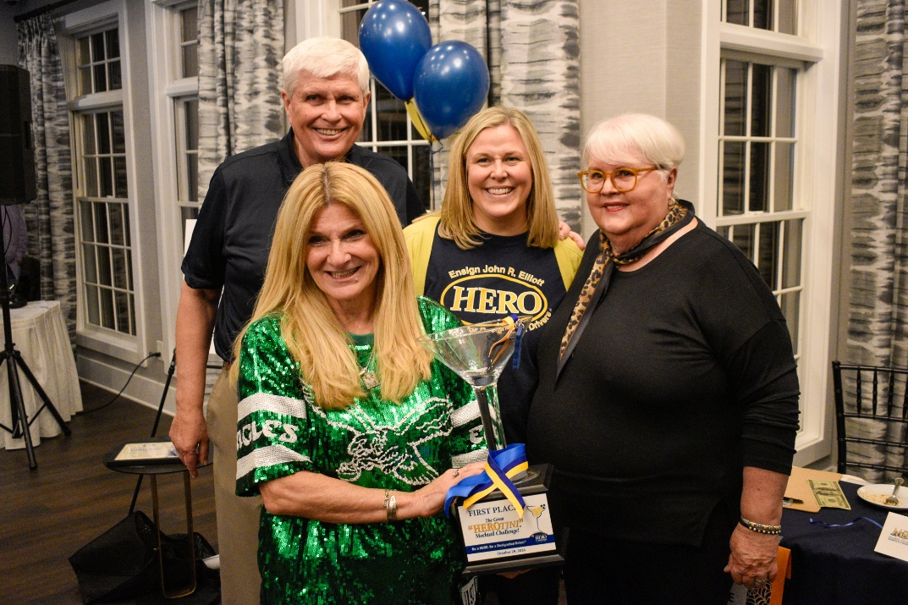

The Windjammer’s Kathy Ryan Hoover and the Elliotts celebrate her victory in the 2024 HEROtini Mocktail Challenge award night festivities held October 29 at Harbor Pines Golf Club

Egg Harbor Township, NJ– The Windjammer Café and Grille in Somers Point was named the winner of the 2024 HEROtini Mocktail Challenge in competition held Tuesday evening at Harbor Pines Golf Club in Egg Harbor Township. The dinner raised $27,000 for the non-profit John R. Elliott HERO Campaign and marked the end to a five-month contest among 27 bars and restaurants to promote non-alcoholic mocktails for designated drivers. Tennessee Beer Hall and Josie Kelly’s Public House took second and third place.

Best-tasting mocktail awards also were presented to Dock’s Oyster House and Linwood Country Club.

The Windjammer raised more than $6,000 from customers and supporters to win the HEROtini Cup trophy for bartender Kathy Hoover and her “Eagletini” green mocktail, a non-alcoholic version of a Bloody Mary cocktail.

During the five-month contest, which began Memorial Day Weekend, the public donated online for their favorite mocktails created by bartenders from each participating establishment. A HEROtini recipe book with ingredients for each drink is now available through the HERO Campaign at info@herocampaign.org

Funds raised in the contest support the HERO Campaign’s mission to end drunk driving by promoting the use of safe and responsible designated drivers in partnership with schools and colleges, police departments, Uber, bar and tavern owners and professional sports teams. Campaign chairman Bill Elliott said the idea for the HEROtini® was his wife Muriel’s invention to promote and reward designated drivers: “They’re the real ‘Life of the Party’ and the cure for drunk driving,” she said.

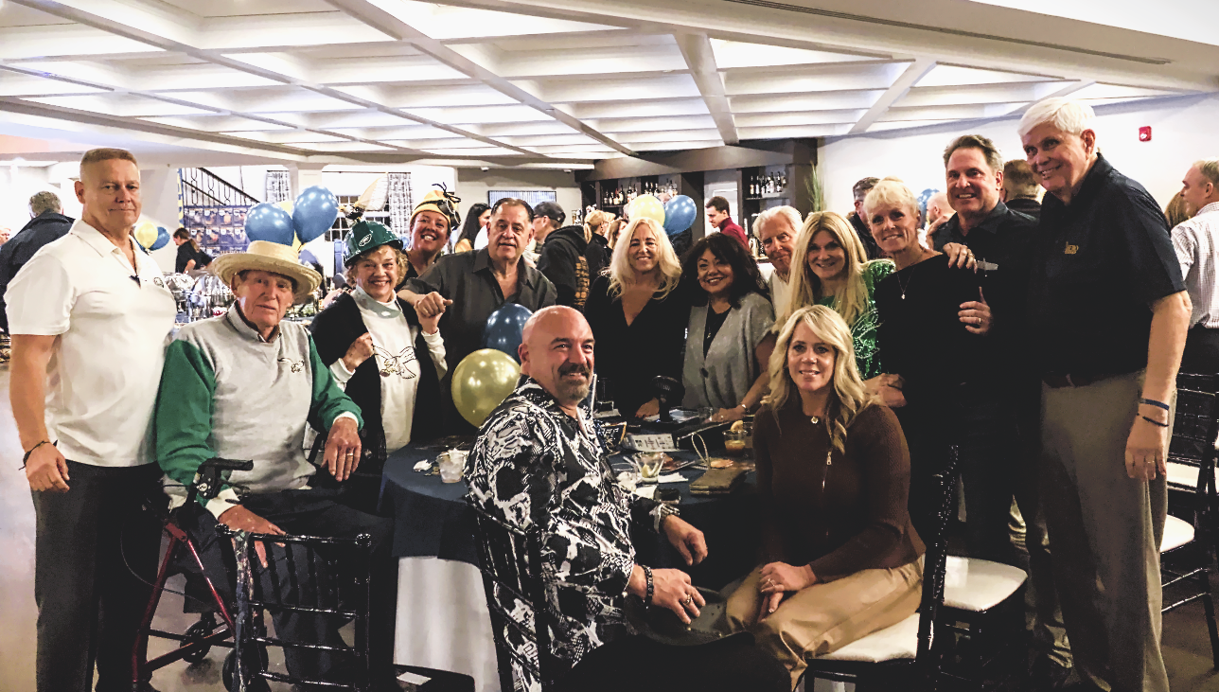

The winning Windjammer team celebrates at the HEROtini Award Night October 29 at Harbor Pines.

# # # #